DevOps Project
CI/CD Pipeline for an Agricultural Market Price Tracker
Task 02: Agile Planning and DevOps Workflow
Name: Aditi Gawari
Branch: CMPN | Division: A
Roll No: 23102A0025 | Batch: 1

- Product Backlog
Priority: High / Medium / Low. Points on a 1–5 scale (1 = trivial, 5 = complex).
ID | Area | Backlog Item | Priority | Points
B01 | Foundation | Define data model (Market, Commodity, PriceRecord, User/Role) | H | 3
B02 | Foundation | Project skeleton, build tool config, local DB schema/migration | H | 3
B03 | Entry | Price-entry form (create) with validation | H | 3
B04 | Entry | Edit/correct existing price record (update) | H | 2
B05 | Entry | Role check — only authorized roles enter/edit | M | 2
B06 | Dashboard | Search API + UI (market, commodity, date range) | H | 4
B07 | Dashboard | Paginated, sortable results list | M | 2
B08 | Summary | Compute today’s avg/modal price per commodity | H | 3
B09 | Summary | Compute % change vs previous reporting day | H | 3
B10 | Summary | Dashboard indicator widgets | M | 2
B11 | Drill-down | Click-through from indicator to record list | M | 2
B12 | Drill-down | Single-record / full-history detail view | M | 3
B13 | Alerts | Rule: flag price change beyond threshold | H | 3
B14 | Alerts | Rule: flag market missing today’s data | M | 2
B15 | Alerts | Alerts/exceptions list view | M | 2

Total points: 39

- User Stories & Acceptance Criteria
B01 — Data model > As a developer, I want a clear data model for markets, commodities, price records > and users, so that every later feature has a stable schema to build on.
– AC1: Given the schema is applied, when I inspect the DB, then Market , tables exist with foreign keys linking PriceRecord → Market and PriceRecord → Commodity , PriceRecord , User Commodity .
- AC2: Given a PriceRecord , when it is saved, then date , min_price , max_price , modal_price , and arrival_qty are all required fields.
B02 — Project skeleton > As a developer, I want a runnable local skeleton, so that I can start building > features immediately.
- AC1: Given a fresh clone, when I run the build command, then the app compiles and starts without manual intervention.
- AC2: Given the skeleton, when I check the repo, then build-tool config (Maven/Gradle/Ant), folder structure, and DB connection config are all present.
B03 — Price entry (create) > As a mandi official, I want to enter a new price record, so that today’s price is > available to everyone searching the app.
- AC1: Given valid market/commodity/price/quantity values, when I submit the form, then a new PriceRecord is created and visible in search within the same session.
- AC2: Given a missing required field, when I submit, then the form is rejected with a field-level error and no record is created.
B04 — Edit price record > As a mandi official, I want to correct a record I entered, so that mistakes don’t > stay live.
- AC1: Given an existing record I own, when I edit and save valid values, then the record updates in place and an updated-timestamp changes.
- AC2: Given invalid edited values, when I save, then the update is rejected and the original record is unchanged.
B05 — Role check > As a system, I want only authorized roles to create/edit price data, so that data > integrity is protected.
- AC1: Given an unauthenticated or read-only user, when they call create/edit endpoints, then the request is rejected (403).
- AC2: Given an authorized data-entry user, when they call the same endpoints, then the request succeeds.
B06 — Search > As any user, I want to search prices by market, commodity, and date range, so > that I can find the exact data I need.
- AC1: Given seed data across 3+ markets, when I search by commodity only, then all matching records across markets are returned.
- AC2: Given a date range with no data, when I search, then an empty-state message is shown (not an error).
B07 — Paginated results > As any user, I want results paginated and sortable, so that large result sets are > usable.
- AC1: Given more than one page of results, when I navigate to page 2, then the correct next set of records is shown.
- AC2: Given a sort-by-price request, when applied, then results are ordered ascending/descending as selected.
B08 — Daily average/modal price > As any user, I want to see today’s average/modal price per commodity, so that I > get a quick read without searching.
- AC1: Given records for a commodity today, when the dashboard loads, then the computed modal price matches a manual recalculation on the same data.
B09 — % change vs previous day > As a farmer, I want to see how much a price moved since yesterday, so that I can > judge whether to sell now.
- AC1: Given yesterday’s and today’s modal price, when displayed, then % change is computed as (today - yesterday) / yesterday * 100 , signed correctly.
- AC2: Given no record for yesterday, when displayed, then the UI shows “no prior data” instead of a broken calculation.
B10 — Dashboard indicator widgets > As any user, I want indicators on the dashboard home, so that I see the market > health at a glance.
- AC1: Given the dashboard loads, when data exists, then at least “today’s avg price”, “% change”, and “markets reporting” widgets render with live values.
B11 — Drill-down from indicator > As any user, I want to click an indicator to see the underlying records, so that > I can verify or investigate a number.
-AC1: Given I click a summary widget, when the drill-down view opens, then it shows exactly the record set used to compute that widget.
B12 — Detail view > As any user, I want a full history for one market+commodity, so that I can see > the trend over time.
- AC1: Given a market+commodity pair with 5+ historical records, when I open detail view, then all records are listed in date order.
B13 — Threshold alert rule > As a farmer, I want to be alerted when a price moves sharply, so that I don’t > miss a good/bad moment to sell.
- AC1: Given a configurable threshold (e.g., 15%), when a new record’s % change exceeds it, then the record is flagged as an alert.
- AC2: Given a change below threshold, when saved, then no alert is created.
B14 — Missing-data rule > As a market analyst, I want to know when a market hasn’t reported today, so that > gaps in coverage are visible.
-AC1: Given a market with no record by the configured cutoff time, when the rule runs, then that market appears in the exceptions list.
B15 — Alerts/exceptions view > As any user, I want a dedicated alerts view, so that exceptions aren’t buried in > the normal dashboard.
- AC1: Given active alerts exist, when I open the alerts view, then all threshold-breach and missing-data exceptions are listed, most-recent first.

- Kanban Board (MVP Sprint)
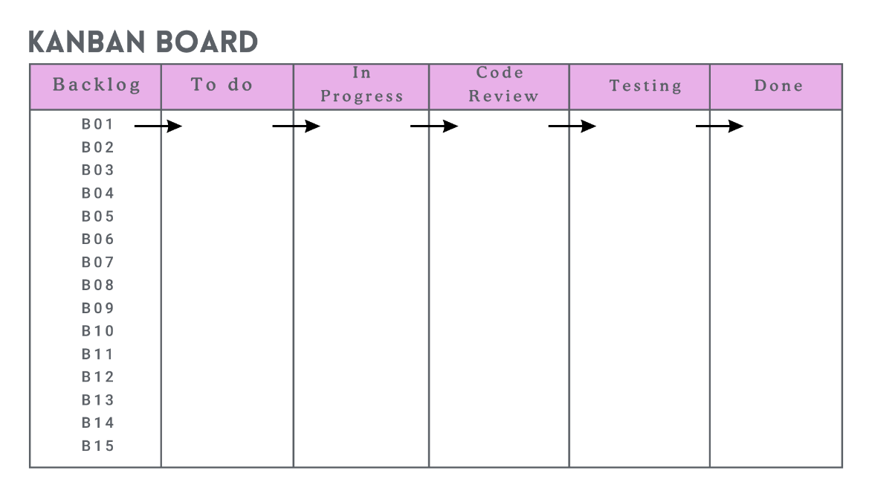
All 15 backlog items start in Backlog and move right; WIP limit of 3 in In Progress to keep focus.
Board policy:
- A card only enters In Progress when its acceptance criteria are already written.
- A card only enters Code Review with an open pull request.
- A card only enters Testing after the reviewer approves and merges.
- A card only enters Done when it meets the Definition of Done.
- Sprint Plan (2-Week MVP Sprint)

Day | Focus | Backlog IDs
1-2 | Foundation | B01, B02
3-4 | Data/Event Entry | B03, B04, B05
5-7 | Searchable Dashboard | B06, B07
8-9 | Summary Indicators | B08, B09, B10
10-11 | Status Drill-Down | B11, B12
12-13 | Alert/Exceptions | B13, B14, B15
14 | Sprint review, backlog grooming for Task 6 (2nd branch/conflict demo, tagging) | -

- Definition of Done (DoD)
A backlog item is Done only when ALL of the following are true:
⃞ Code implements all stated acceptance criteria.
⃞ Feature branch created with a clear name ( feature/- ).
⃞ At least one meaningful commit history (not a single squashed blob).
⃞ Pull request opened, reviewed (self-review acceptable for solo project, but review comments must be recorded), and merged to develop.
⃞ No build warnings/errors in the CI build (from Task 7 onward).
⃞ Relevant Selenium test (for the 3–5 critical journeys) passes locally and, once Task
10 is reached, in Jenkins.
⃞ No secrets/credentials committed.
⃞ Documentation/README updated if the change affects setup or usage.

- DevOps Lifecycle Diagram
